Important! Please Read Thoroughly.
Culver City High School
4401 Elenda Street
Culver City, Ca 90230
California Scholarship Federation
Chapter No. 482 SC
September 14, 2011 Fall Semester 2011

Dear: ___________________________________________ Period: _______ Room: _______

According to our records, you may qualify for California Scholarship Federation for Fall 2011. CSF is a statewide organization that honors outstanding high school students. Membership is based on semester grades earned during your 10th, 11th, and 12th grade years. A’s and B’s on your previous semester report card are allotted points which added together may result in your membership. Membership in CSF looks great on college applications. Students that qualify for four or more semesters will receive honors and will be recognized at graduation.

Students in 10th grade may submit an application for the Spring Semester of 9th grade. Students that qualify will be deemed Associate CSF Members. However, 9th Grade will not count toward Honors (see below).

Please fill out the attached application and return to Ms. Gonzalez in the Guidance Office no later then 4:00 PM on Friday, September 30, 2011. Your membership for last semester will only go into effect if you return the application on time. No late applications will be accepted without a readmit. Please do not wait until the last minute; the deadline stands according to the CSF by-laws. Also, please do not leave applications in Ms. Gonzalez’s mailbox. There is no guarantee that it will be received. If you have any questions see Ms. Gonzalez in the Guidance Office.

Lastly, make sure you read all of the directions.

Thank you,
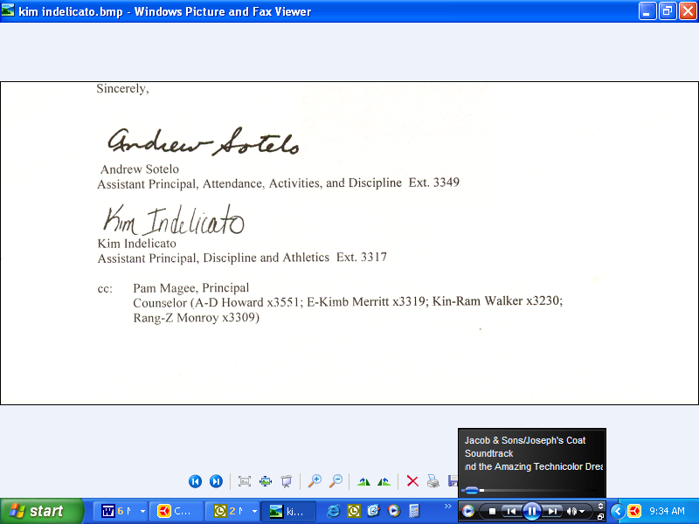

Ms. Kim Indelicato - CSF Advisor
CSF Graduation Qualifications
Grades 10-12 Only
HONORS
Requirement:
- 4 or 5 Semesters CSF Member
- Must include at least one semester during your senior year
What you will receive:
- Gold Seal on Diploma
- CSF Lamp Pin
- Gold CSF Tassel
- Gold Cords
- Life Membership Certificate

HIGHEST HONORS
Requirement:
- 6 Semesters CSF Member
- You must be a CSF Member ALL 6 semesters
What you will receive:
- Gold Stole
- Gold Seal on Diploma
- CSF Lamp Pin
- Gold CSF Tassel
- Gold Cords
- Highest Honors Certificate

